Students Entering Grade 3
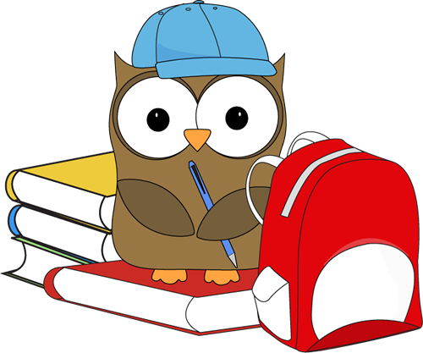

Summer Reading Suggestions
2015

Children entering Grade 3 shift their focus from learning to read to reading to learn.
They should be encouraged to read longer books for a longer period of time in one sitting.
Rising third graders enjoy character-driven books, especially series books that will sustain their interest. They also enjoy contemporary fiction, nonfiction, legends, fables, myths, and biographies. Through this variety of reading materials, students will expand their vocabulary and interpret ideas within the texts. They should have the opportunity to select books of interest which will keep them reading and learning.

Find tips on how to help your child read nonfiction at
http://imaginationsoup.net/2011/06/help-your-child-read-and-comprehend-non-fiction/
What other books might a third-grader enjoy? Visit this site for more suggestions:
http://imaginationsoup.net/best-books-8-year-olds/

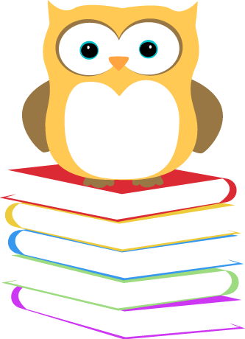

The Five Finger Rule

There are so many great books from which to choose. How do you know if a book is right for you? Try the “Five Finger Rule” to help you select just the right book.

Open the book to a full page of text, and begin to read.
Hold up a finger for every word you come to that you cannot pronounce or do not know.

0 - 1 finger...easy
2 - 3 fingers...just right
4 - 5 fingers...hard

If you get 5 fingers up on one page, the book is too difficult to read independently, but it may be fine to read with someone.

If you do not get any fingers up, but are reading very slowly and sounding out almost every word, you may not enjoy the book. This book might be better if someone reads it to you first, then you try it independently.

By using the Five Finger Rule, you are practicing to remember more words, read more smoothly, read faster and read with expression.

The Caldecott Medal is awarded each year by the American Library Association (ALA) to honor the illustrator who had created the most distinguished children’s picture book published during the preceding year. The award was named in honor of nineteenth-century English illustrator Randolph Caldecott.

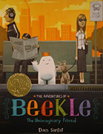
2015 Medal Winner

This magical story begins on an island far away where an imaginary friend is born. He patiently waits his turn to be chosen by a real child, but when he is overlooked time and again, he sets off on an incredible journey to the bustling city, where he finally meets his perfect match and-at long last-is given his special name: Beekle.

2015 Honor Books
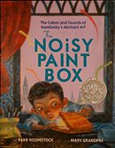
Vasya Kandinsky was a proper little boy: he studied math and history, he practiced the piano, he sat up straight and was perfectly polite. And when his family sent him to art classes, they expected him to paint pretty houses and flowers--like a proper artist.
But as Vasya opened his paint box and began mixing the reds, the yellows, the blues, he heard a strange sound--the swirling colors trilled like an orchestra tuning up for a symphony! And as he grew older, he continued to hear brilliant colors singing and see vibrant sounds dancing. But was Vasya brave enough to put aside his proper still lifes and portraits and paint . . .music?
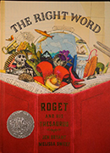
For shy young Peter Mark Roget, books were the best companions -- and it wasn't long before Peter began writing his own book. But he didn't write stories; he wrote lists. Peter took his love for words and turned it to organizing ideas and finding exactly the right word to express just what he thought. His lists grew and grew, eventually turning into one of the most important reference books of all time.
Pictures from - http://www.ala.org/alsc/awardsgrants/bookmedia/caldecottmedal/caldecottmedal
Descriptions from - titlewave.com

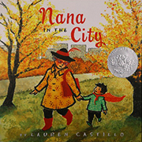
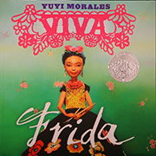
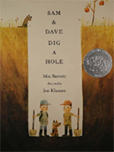
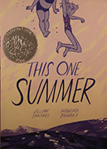

A young boy is frightened by how busy and noisy the city is when he goes there to visit his Nana.
She makes him a fancy red cape that keeps him from being scared as she shows him how wonderful a place the city can be.
Text in English and Spanish.

Introduces the reader to Mexican artist Frida Kahlo.
Sam and Dave are on a mission to find something spectacular. So they dig a hole. And they keep digging. And they find . . . nothing. Yet the day turns out to be pretty spectacular after all.
Attentive readers will be rewarded with a rare treasure in this witty story of looking for the extraordinary -- and finding it in a manner you'd never expect.
Rose and her parents go on vacation to Awago Beach like they do every year, but this year Rose's mom and dad won't stop fighting and she turns to her friend Windy for help dealing with her troubled family life.

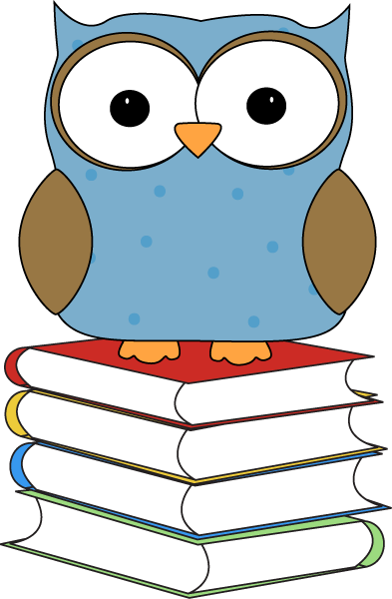

The following book lists have been compiled from 2 sources: the American Library Association’s 2015 Notable Book List and Children’s Choice Book Awards at Children's Choice Awards 2015 .
Each year, the ALA recognizes “notable” books, books that are especially outstanding in their field, and encourage children’s interests. These exemplary books can be picture books, works of fiction, information books, or poetry for children birth through age 14. For a complete list of ALA’s Notable Books and go to: http://www.ala.org/alsc/awardsgrants/notalists/ncb

The Adventures of Beekle: The Unimaginary Friend. By Dan Santat. Illus. by author.
In four delightful chapters, Beekle, an imaginary friend, undergoes an emotional journey looking for his human. Vibrant illustrations add to the fun. (2015 Caldecott Medal Book)

Blizzard. By John Rocco. Illus. by the author.
Blizzard is based on author’s childhood experience during the now infamous Blizzard of 1978, which brought fifty-three inches of snow to his town in Rhode Island. Told with a brief text and dynamic illustrations, the book opens with a boy's excitement upon seeing the first snowflake fall outside his classroom window. It ends with the neighborhood's immense relief upon seeing the first snowplow break through on their street. This book about the wonder of a winter storm is as delicious as a mug of hot cocoa by the fire on a snowy day

A Boy and a Jaquar. By Alan Rabinowitz. Illus. by CáTia Chien.
Alan loves animals, but the great cat house at the Bronx Zoo makes him sad. Why are they all alone in empty cages? Are they being punished? More than anything, he wants to be their champion--their voice--but he stutters uncontrollably. Except when he talks to animals...Then he is fluent. This real-life story explores truths not defined by the spoken word, and encourages Alan to become a zoologist and conservationist known around the world.

Feathers: Not Just for Flying. By Melissa Stewart. Illus. by Sarah S. Brannen.
Young naturalists meet sixteen birds in this elegant introduction to the many uses of feathers. A concise main text highlights how feathers are not just for flying. More curious readers are invited to explore informative sidebars, which underscore specific ways each bird uses its feathers for a variety of practical purposes.

Handle with Care: An Unusual Butterfly Journey, By Loree Griffin Burns. Photographs by Ellen Harasimowicz.
In this handsome book with glorious photographs, children can follow the life cycle of a butterfly from a farm in Costa Rica to a live museum exhibit in the U.S.

Kali's Story: An Orphaned Polar Bear Rescue. By Jennifer Keats Curtis. Ilus. by John Gomes.
Follow the rescue of orphaned polar bear cub, Kali, from the Inupiat village of Point Lay to the Alaska Zoo in Anchorage to his new home at the Buffalo Zoo in New York. This photographic journey beautifully captures the remarkable development of the cub, who initially drinks from a baby bottle, sucks his paw for comfort, and sleeps with a “blankie” as he rapidly grows into the largest land carnivore on earth.

Little Melba and Her Big Trombone. By Katheryn Russell-Brown. Illus. by Frank Morrison.
This is beautifully illustrated biography of African American musician, Melba Doretta Liston, a self-taught prodigy and world-class trombone player, composer, and arranger who played the trombone and composed and arranged music for many of the great jazz musicians of the twentieth century.

Little Roja Riding Hood. By Susan Middleton Elya. Illus. by Susan Guevara.
While Roja picks flowers on the way to her grandma's, a mean wolf sneaks away with her cape to surprise Abuelita. But Grandma's no fool and Roja's no ordinary chica. They send that hungry lobo packing with a caliente surprise!
This sassy retelling of Little Red Riding Hood has accessible Spanish rhymes and fresh illustrations, with hip cultural details throughout.

Mama Built a Little Nest. By Jennifer Ward. Illus. by Steve Jenkins.
Lively couplets describe birds and the nests they build for their young, while beautiful cut-paper collages are a feast for children's natural curiosity.

The Noisy Paint Box: The Colors and Sounds of Kandinsky's Abstract Art. By Barb Rosenstock, Illus. by Mary Grandpré.
The story of abstract artist Vasily Kandinsky, who (due to a neurological condition) experienced colors as sounds, and sounds as colors, created work that was bold and groundbreaking. (2015 Caldecott Honor Book)

Once Upon an Alphabet. By Oliver Jeffers. Illus. by the author. Penguin/Philomel.
A creative, fresh take on the alphabet book! Jeffers tells a short story for each letter, giving each one its due glory. Full of humor and whimsy. Complete with distinctive illustrations that are one of a kind.

Tiny Creatures: The World of Microbes. By Nicola Davies, Illus. by Emily Sutton. Candlewick.
A picture book that explores the different microbes that inhabit the Earth and examines the varied jobs they do. Young readers are introduced to this new world through simple descriptions, colorful examples, and concise writing.

Weeds Find a Way. By Cindy Jenson-Elliott. Illus. by Carolyn Fisher.
Weeds are wonderful! Persistent, exuberant…these plants have personalities, and this nonfiction picture book puts them on colorful display! From bright yellow dandelions popping through cracks in sidewalks to purple loosestrife growing rampant along roadways, weeds offer unexpected splashes of color and life to the least likely of places.

Zombie in Love. By Kelly DiPucchio. Ilus. by Scott Campbell.
Mortimer is looking for love. And he’s looking everywhere! He’s worked out at the gym (if only his arm wouldn’t keep falling off). He’s tried ballroom dancing lessons (but the ladies found him to be a bit stiff). He’s even been on stalemate.com. How’s a guy supposed to find a ghoul? When it seems all hope has died, could the girl of Mortimer’s dreams be just one horrifying shriek away?

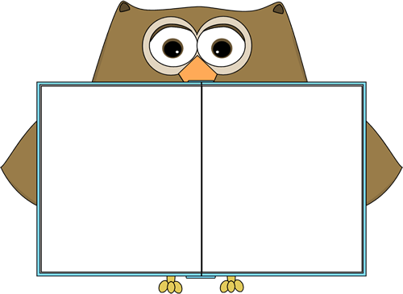
Favorite
Book Series

Amber Brown series by Paula Danziger http://www.beverlycleary.com/
Animal Ark series by Ben Baglio http://www.scholastic.com/teachers/bookwizard/books-by/ben-m-baglio#cart/cleanup
A to Z Mysteries by Ron Roy http://www.ronroy.com/atoz
Babymouse series by Jennifer Holm http://www.randomhouse.com/kids/babymouse/homepage.htm
Bailey School Kids series by Debbie Dady http://www.debbiedadey.com/Swamp/Meet/
Boxcar Children series by Gertrude Warner http://www.boxcarchildren.com/
Fudge Books: Superfudge, Fudge-a-mania, and Double Fudge by Judy Blume http://judyblume.com/books/fudge.php
Humphrey series by Betty Birney http://bettybirney.com/humphrey.html
Judy Moody series by Megan McDonald http://www.judymoody.com/
Little House on the Prairie series by Laura Ingalls Wilder http://www.littlehousebooks.com/books/
Nate the Great series by Marjorie Sharmet http://www.randomhouse.com/kids/natethegreat/
Ramona series by Beverly Clearly http://www.beverlycleary.com/
Who Was...Biography series published by Penguin Books http://www.penguin.com/static/packages/us/yreaders/books4boys/series_whowas.php



This Summer, Take a Break and Read - Student who read during the Summer perform better in the fall. Brochure by Penguin Young Readers Group. Go to: www.penguin.com/summerreading

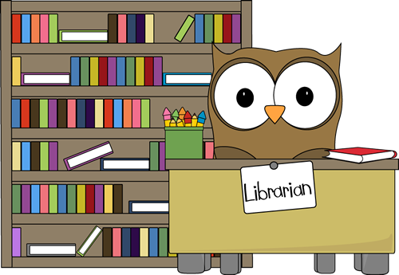
Compiled by

Mrs. A. Petrilli
Millington School Library Media Specialist
June 2015
clipart from http://www.mycutegraphics.com/graphics/classroom-job-images.html

